Find Median of Sorted Arrays
Given two sorted arrays num1 and num2 of lengths m and n respectively, find the median of the two arrays combined. Your solution must achieve a time complexity of O(log(min(m, n))).
Input
- num1 (list of int) — first sorted array in ascending order
- num2 (list of int) — second sorted array in ascending order
For example, given num1 = [1, 3, 8] and num2 = [7, 9, 10, 11]:
- The combined sorted array would be [1, 3, 7, 8, 9, 10, 11]
Output
A single number, the median of the combined sorted array.
If the combined length is odd, return the middle element. If the combined length is even, return the average of the two middle elements as a float.
For the example above:
8
The combined array [1, 3, 7, 8, 9, 10, 11] has 7 elements (odd), so the median is the 4th element: 8.
Task
Complete the find_median_sorted_arrays function and return the median of the combined sorted array.
Initial Approach:
class Solution:
def find_median_sorted_arrays(self, num1, num2):
num3 = num1+num2
num3.sort()
len3 = len(num3)
median_index = (len3-1) / 2
if isinstance(median_index, int):
return num3[median_index]
else:
return (num3[math.floor(median_index)] + num3[math.ceil(median_index)])/2
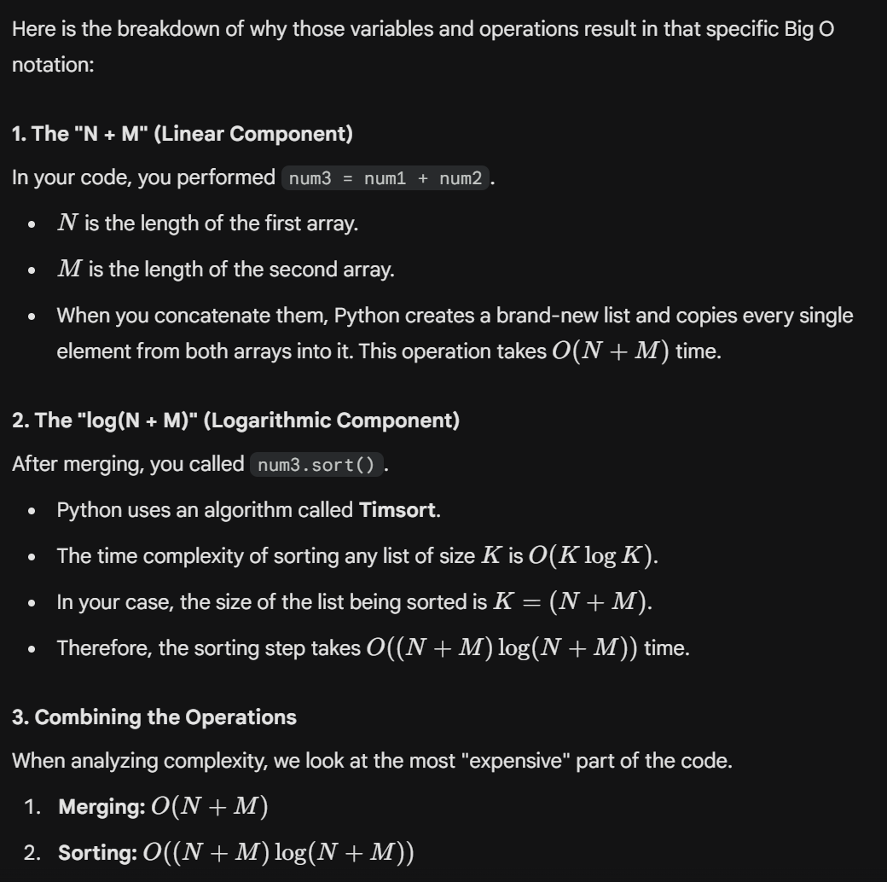

Suggested Approach:
if len(num1) > len(num2):
num1, num2 = num2, num1 # Ensure num1 is the smaller array
m, n = len(num1), len(num2)
imin, imax, half_len = 0, m, (m + n + 1) // 2
while imin <= imax:
i = (imin + imax) // 2
j = half_len - i
if i < m and num1[i] < num2[j - 1]:
imin = i + 1 # i is too small, move right
elif i > 0 and num1[i - 1] > num2[j]:
imax = i - 1 # i is too big, move left
else:
max_of_left = 0
if i == 0:
max_of_left = num2[j - 1]
elif j == 0:
max_of_left = num1[i - 1]
else:
max_of_left = max(num1[i - 1], num2[j - 1])
if (m + n) % 2 == 1:
return max_of_left # Odd total length
min_of_right = 0
if i == m:
min_of_right = num2[j]
elif j == n:
min_of_right = num1[i]
else:
min_of_right = min(num1[i], num2[j])
return (max_of_left + min_of_right) / 2.0 # Even total length

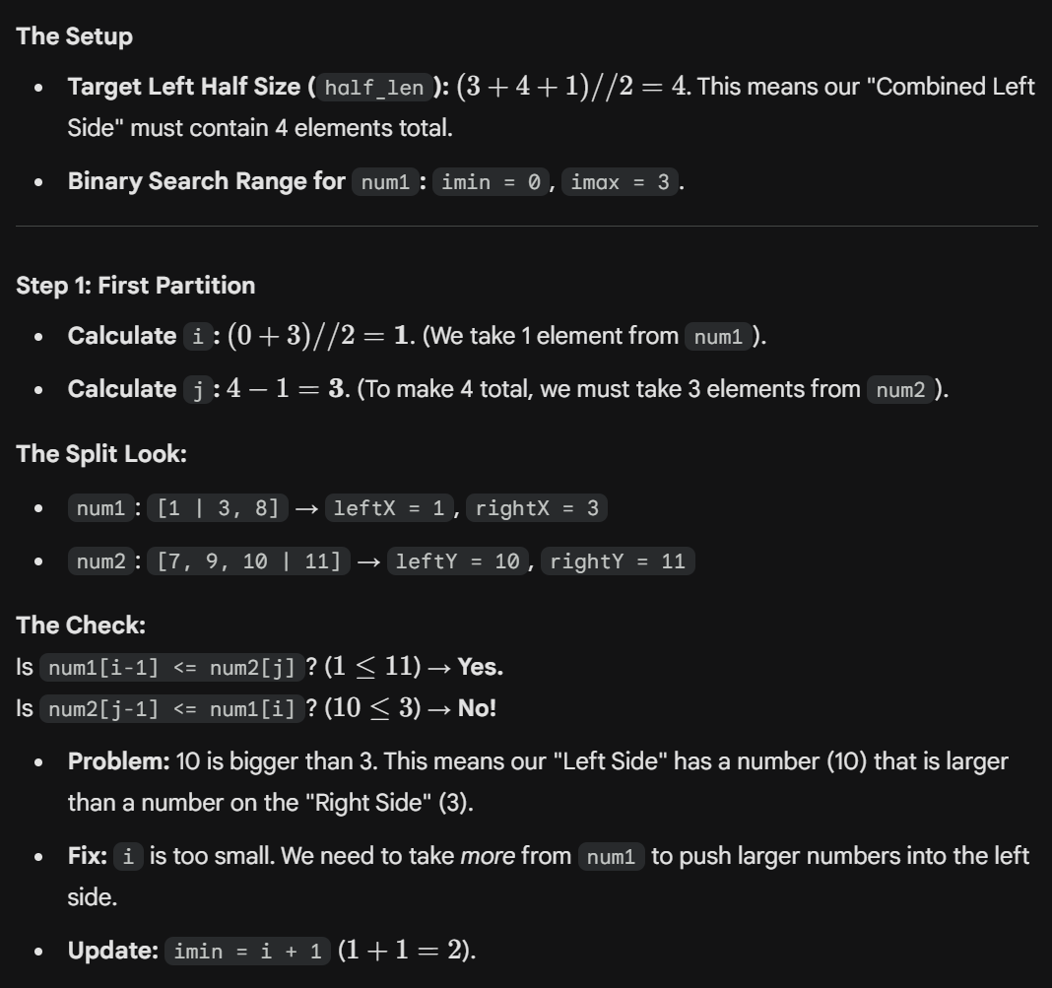
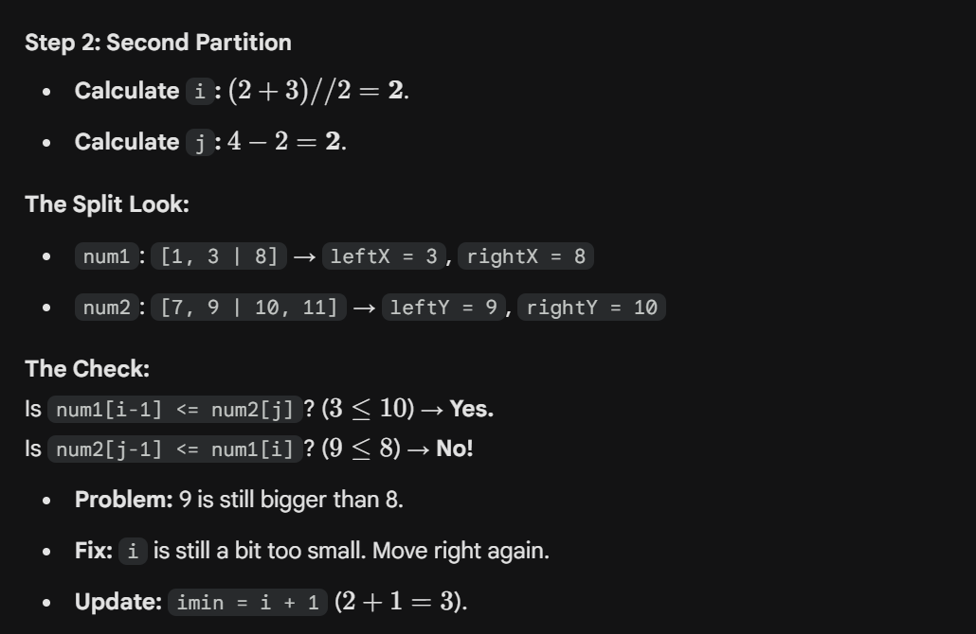
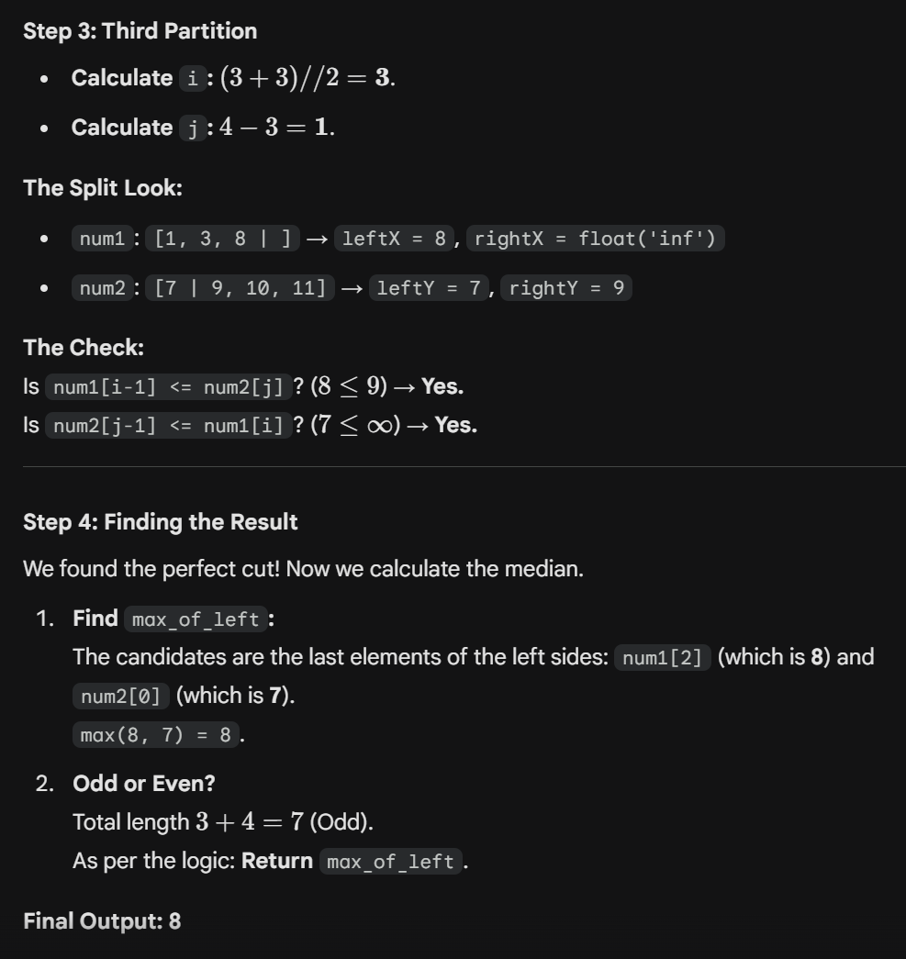
Find Peak Element
You are given an integer array nums of length n. A neighbour of an element nums[i] refers to the adjacent elements nums[i-1] and nums[i+1] (if they exist). An element nums[i] is called a peak element if it is strictly greater than its neighbours.
For convenience, assume that nums[-1] = nums[n] = -infinity. You may assume at least one peak element always exists in the array.
Design an algorithm to find the index of any peak element in O(log n) time.
Input
- nums (list of int), an integer array
For example, given nums = [1, 2, 3, 1]:
- Index 0: value 1, less than its right neighbour 2 — not a peak
- Index 2: value 3, greater than both neighbours (2 and 1) — peak
Output
A single integer — the index of any peak element.
For the example above:
2
Element at index 2 has value 3, which is greater than both its neighbours. If multiple peaks exist, returning any valid peak index is accepted.
Task
Complete the find_peak function and return the index of any peak element within the array.
